UNIT: Career Development Grade Level 1
ACTIVITY: Careers A-Z Lesson 3

Career Standards: A. Students will acquire the skills to investigate the world of work in relation to knowledge of self and to make informed career decisions.
C. Students will understand the relationship between personal qualities, education, training and the world of work.

Competencies: C:A1 Develop Career Awareness
C:C1 Acquire Knowledge to Achieve Career Goals

Indicators: C:A1.2 Learn about the variety of traditional and nontraditional occupations
C:A1.3 Develop an awareness of personal abilities, skills, interests and motivations
C:C1.6 Understand the importance of equity and access in career choice

Materials:

- A-Z alpha list
- When I Grow Up by P.K. Hallinan
- Community Helper Pocket Flash Cards (2 complete sets)

Vocabulary:

- Job - work
- Career – a job someone does for work

Gathering:

Show A-Z alpha list on overhead or elmo, or write A-Z on board or chart paper. Ask students to name different jobs. As students name jobs, write their ideas under the appropriate letter the word begins with. Do as many examples as gathering time allows. (Five to ten depending on pace of activity.)

Review Agenda/Before the Lesson:

“On the count of three, what job did Matthew have from our story last week?” Write “painter” or “artist” under the appropriate letters. “It is very important for all people to have dreams about what they want to be when they grow up, just like Matthew had in the last lesson. Today, we will read a story about different jobs using the alphabet. As we read the story, pay attention so you can name different jobs to add to our alpha list. The book will give us a lot of new ideas!”

During the Lesson:

Read the book. Throughout the book, emphasize how both boys and girls can have every job included. “Both boys and girls can be good at whatever job they want, as long as they believe in themselves and try hard.”

After the Lesson:

Place four career cards and four matching tool cards on the elmo. Have students come up and find the matching career card to the corresponding tool card. Other option: Divide students into dyads or triads. Give each group 4 or 5 sets of Community Helper Pocket Flash Cards (career cards and career tool cards). Demonstrate (model) to students how to work together to match careers to the appropriate tools. As they work, encourage groups to talk about each career and the tools they use.

Checking Out What You Learned/Assessment:

Ask students to name jobs they learned about in their game or in the book that were not mentioned at the beginning of the lesson. (Jobs/careers that are not written on the board.) As students share their ideas, ask the whole class to share what letter each job would fall under. Add jobs to existing list. Counselor can opt to use a different color marker to show additional careers learned throughout the lesson.

Closing:

Instruct students to look at the board. “These are just a few careers or jobs you could dream about having when you grow up. You might have a dream to do one right now. Your dreams might change when you grown up and that’s okay – as long as you keep making them!”

Reflective Questions:

What did my students gain from this lesson?
How did it impact their thinking, attitudes and abilities?
What things did I do well? How did I know?
In what way did the strategies I used enhance learning?
How does my assessment meet my lesson objective?

Notes:

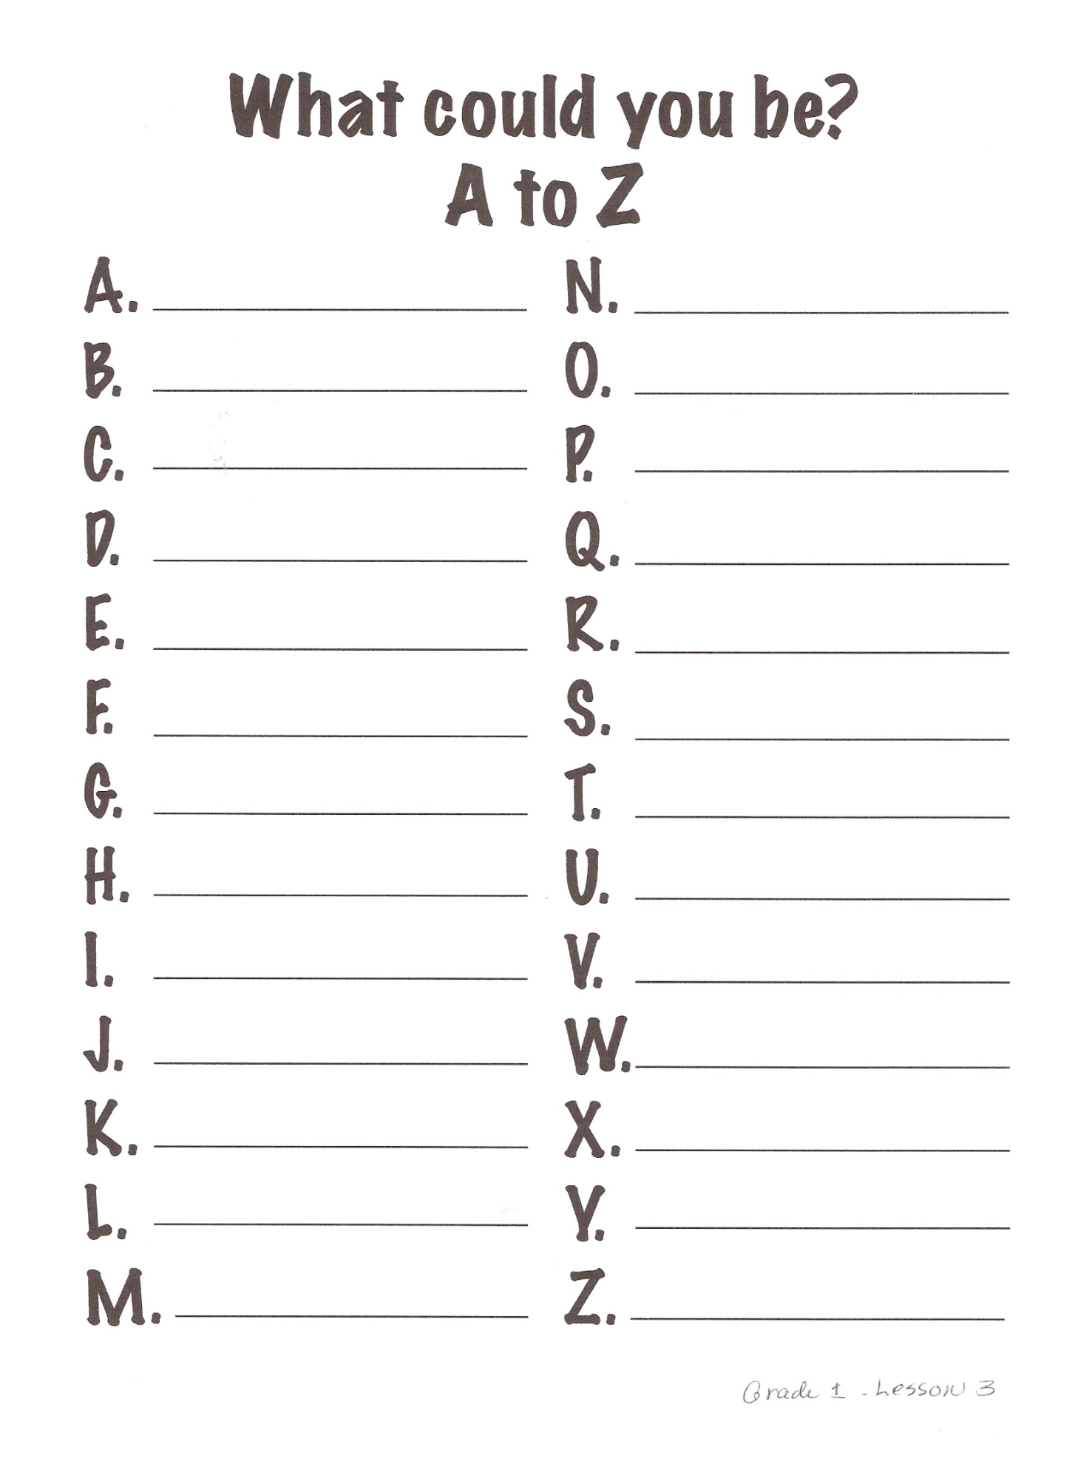
Career Unit, Des Moines Elementary School Counseling

