# UNIT: Bullying prevention Grade Level: K-2

ACTIVITY: What can I do when I see bullying? Lesson 4

___________

Standards: A: Students will acquire the knowledge, attitudes and inter-personal skills to help them understand and respect self and others.

B: Students will make decisions, set goals and take necessary action to achieve goals.

Competencies PS:A.1 Acquire Self-knowledge

PS:A.2 Acquire Interpersonal Skills

PS:B.1 Self-knowledge Application

Indicators: PS:A1.6 Distinguish between appropriate and inappropriate behavior

PS:A2.3 Recognize, accept, respect and appreciate individual differences

PS:A2.6 Use effective communication skills

PS:B1.3 Identify alternative solutions to a problem

____________________________________________________________________

**Materials:**

* *Trouble in the Barker’s Class* by Tommy DePaola (K-1st)

Morgie and Muffy, along with their classmates, plan a variety of activities to welcome the new student. However, when Carole Ann arrives she will not smile, join in the activities, and shows no respect to the class. The children make a plan to combat this kind of bully.

* *Bully B.E.A.N.S.* by Julia Cook (2nd) OR
* “When you See a Bully” video by Sunburst, (14 min.) on Heartland AEA, Learn 360

(K-2nd)

* Jelly Beans (optional)
* Bully B.E.A.N.S. Activity and Idea Book by Julia Cook
* Activity sheet “What Would You Do?” From Safe and Caring Schools, 1-2 (2nd) p. 110

Related Materials:

* Youtube video for Bully Beans(2nd): http://www.youtube.com/watch?v=JZdhWceysvg

**Vocabulary:**

* Bystander - a person that is watching when something happens without doing anything
* Courageous - a way of being brave

**Gathering:**

Ask students what response is better by reading the following situations and responses.

* “You hear someone saying mean things to another person. Should you join in by saying mean things to that person or repeat the mean things you heard? The next time you see the person, should you make a mean face and roll your eyes at her?” (*Inappropriate response)* “Or should you tell them to STOP saying mean things and don’t join in, or repeat the mean things. Be a friend to the person being bullied.” *(Appropriate response)*
* “Three friends are playing together and another person tries to join in. Two of the people say she can’t play. Do you agree that she can’t play with you? (*Inappropriate Response)* “Or do you tell them to ‘STOP IT’ and invite her to play with you?” (*Appropriate Response)*
* “Have you ever seen anybody get bullied by someone? What happened?”

**Review Agenda/Before the Lesson:**

Popcorn around the room and ask students to name one thing they can do if they see bullying. Then state the purpose of this lesson is to know what to do when you see other students being bullied. Tell them to think about this during the book or video.

**During the Lesson:**

**For K-1 students:** Have students predict what kind of trouble will happen in Mrs. Barker’s class.

Then read the book to students and ask some of the following questions during the reading:

* How do the children plan to welcome the new girl to class?
* What did Carole Anne do when Ms. Shepherd introduced her to the children?
* What did Carole Anne do when the children told her to stop pushing in line?
* What did Carole Anne do when Morgie tried to find out why she scribbled on his book?
* Morgie and Moffie are trying to figure out what to do. What does the class decide to do the next day in school?
* What happens when Ms. Shepherd tries to talk to Carole Anne about this problem?
* What happens when Morgie finds Carole Anne alone and lost?

**For 2nd grade**: First, show students some jelly beans and tell them that you are going to eat them so you can deal with the bullying behaviors in this book. Then ask some of the following questions during the reading of *Bully B.E.A.N.S:*

* What did Bobbette do and say in the book?
* What are bully beans?
* How did the bully beans help the children stop the bullying?
* Do you really need bully beans to stop bullying? If not, what do you really need?
* What did all the children do to stop the bullying?
* Were any of the children bystanders in this book? Why or why not?

**If watching the video**: ask the following questions after the video:

* What did Ben learn to do when he saw Jason being bullied?
* What did Morgan and her friends do to help Tracy from being bullied?
* What did Chloe do to help Ryan when he was bullied?

**After the Lesson:**

**For K-1 students**: Have students come up and role-play the following situations with you:

* An older boy picks on one of your friends by taking his stuff away from him and you see this happening every day.
* Sarah is taller than the other kids and other kids make fun of her by calling her “giant” at recess time. You feel sad but don’t do anything about it.
* In the bathroom, you see a boy pushing another boy on the floor and you leave the bathroom right away because you are scared.
* Day after day, a girl cuts in front of your friend and says “I told you I am ahead of you in line”. She lets the girl cut in front of her every day when the teacher isn’t looking.

**For 2nd grade students**: Have students complete the activity sheet together with a partner or individually. If you are reading the *Bully B.E.A.N.S* book, you could share jelly beans with them and have them use the activity from page 10 of the Bully Beans Activity and Idea Book. (Due to copyright we are not allowed to reproduce that activity sheet).

**Checking Out What You Learned/Assessment**:

**For K-1 students**: Observe the role-play interactions and use that as an assessment of what students have learned about what to do as a bystander when bullying happens.

**For 2nd grade students**: Have students share out the answers to their activity sheet.

**Closing:**

Pretend we see someone being bullied. Let’s all stand up against bullying. All together let’s say: Stop bullying now!!!! We don’t want *Trouble* in______(fill in your name)___’s_____ Class, do we?

**Reflective Questions:**

*What did my students gain from this lesson*?

*How did it impact their thinking, attitudes and abilities*?

*What things did I do well*? *How did I know?*

*In what way did the strategies I used enhance learning*?

*How does my assessment meet my lesson objective*?

**Notes:**

You could have students watch the bully beans youtube video as a supplement to this lesson and have them compare the book and the video using a Venn diagram.

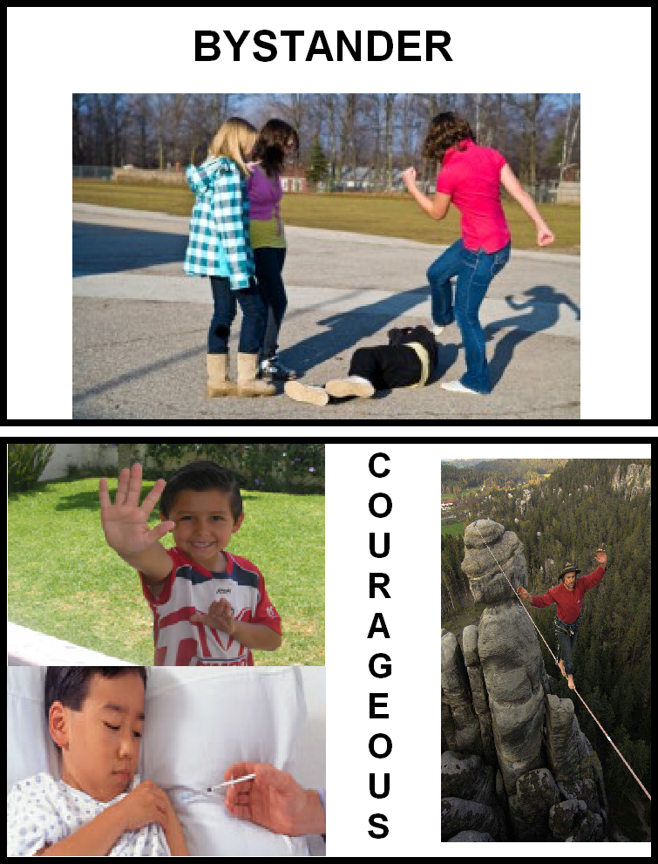

Name ______________________

“What Would You Do?” Activity Sheet

|  |  |  |
| --- | --- | --- |
| When Jimmy was being bullied by Mike and Pete, Joe got friends together to get Jimmy away from them. | Was this courageous?  C:\Users\striblinja\AppData\Local\Microsoft\Windows\Temporary Internet Files\Content.IE5\WKYL80DD\MC900423171[1].wmf Yes  C:\Users\striblinja\AppData\Local\Microsoft\Windows\Temporary Internet Files\Content.IE5\55NAFSVG\MC900423165[1].wmf No | What would you do? |
| When Jenny saw David and Carlos picking on Mario, she thought it was funny and joined in. | Was this courageous?  C:\Users\striblinja\AppData\Local\Microsoft\Windows\Temporary Internet Files\Content.IE5\WKYL80DD\MC900423171[1].wmf Yes  C:\Users\striblinja\AppData\Local\Microsoft\Windows\Temporary Internet Files\Content.IE5\55NAFSVG\MC900423165[1].wmf No | What would you do? |
| When LaShanda wouldn’t let Shari join the game, Annette decided to play with Shari anyway. | Was this courageous?  C:\Users\striblinja\AppData\Local\Microsoft\Windows\Temporary Internet Files\Content.IE5\WKYL80DD\MC900423171[1].wmf Yes  C:\Users\striblinja\AppData\Local\Microsoft\Windows\Temporary Internet Files\Content.IE5\55NAFSVG\MC900423165[1].wmf No | What would you do? |

Taken from Safe and Caring Schools (Grades 1-2) p. 110.