UNIT: Career Development Grade Level 4
ACTIVITY: Follow Your Dreams Lesson 1

Career Standards: A. Students will acquire the skills to investigate the world of work in relation to knowledge of self and to make informed career decisions.
Competencies: C:A1 Develop Career Awareness
C:A2 Develop Employment Readiness
Indicators: C:A1.3 Develop an awareness of personal abilities, skills, interests, and motivations
C:A1.8 Pursue and develop competency in areas of interest
C:A2.7 Develop a positive attitude toward work and learning

Materials:

- Image of The Crow and the Pitcher (image from Project Gutenberg)
- The Crow and the Pitcher an Aesop Fable (text taken from Project Gutenberg)
- Picture of students of different sizes
- Dancing in the Wings by Debbie Allen
- Venn Diagram comparing the book and fable

Related Materials:

- Jose! Born to Dance by Susanna Reich (This is a nonfiction book.)
- America’s Champion Swimmer by David Adler (This is a nonfiction book.)
- Salt in His Shoes by Deloris Jordan

Vocabulary:

- Persevere – to keep working at something even if it’s hard; never giving up
- Goal – something a person wants to accomplish; often requires effort and hard work
- Dream – something you hope will happen someday

Gathering:

Put the image of The Crow and the Pitcher on the overhead or elmo. Read the following or have students in the class read: The Crow and the Pitcher an Aesop fable.

“A Crow, half-dead with thirst, came upon a Pitcher which had once been full of water; but when the Crow put its beak into the mouth of the Pitcher he found that only very little water was left in it, and that he could not reach far enough down to get at it. He tried, and he tried, but at last had to give up in despair.

Then a thought came to him, and he took a pebble and dropped it into the Pitcher. Then he took another pebble and dropped it into the Pitcher. He kept doing this until at last, he saw the water mount up near him, and after casting in a few more pebbles he was able to quench his thirst and save his life.”

- Ask: “The crow kept working until he got his job done – what was his job?” “What would have happened if he gave up?” “What did the crow learn?”
- Connect to study skills lessons in 4th grade – assuming study skills is taught prior to career development. (i.e. effort is needed to accomplish goals)
- Reinforce vocabulary here: persevere, goal and dream

Review Agenda/Before the Lesson:

Use a picture with students of different sizes and ask: “Can these students be what they want to be when they grow up even though they are different in some way?” “Can a basketball player be shorter; can a dancer be taller?”

“Today we will learn how to persevere and follow our dreams – no matter who we are, what we look like, or how difficult our goals seem.”

During the Lesson:

Choose one of the four books listed under the “Materials” and “Related Materials” sections. If you use Dancing in the Wings, use the following summary of the book and questions to guide your processing: “Sassy dreams of being a dancer, but she is too tall to dance in the chorus with the others. Despite the laughter and teasing, she works to prove herself and learns that being different can be an asset.”

Read Dancing in the Wings. Stop to talk about some or all of the following questions:
- “What is Sassy’s dream?”
- “What did the children in the story tease Sassy about?”
- “What did Uncle Redd say to Sassy to make her feel better?”
- “Mr. Debato calls all the other girls over to him and leaves Sassy standing by herself. How does she feel at that moment?”
- “How does Sassy overcome her fear of being too tall and reach her dream?”

After the Lesson:

Have students compare similarities and differences between the fable in the gathering and the book using a Venn diagram.

Checking Out What You Learned/Assessment:

Record their responses on the Venn diagram as a way of assessing their ability to see that one needs to persevere even though there may be obstacles to our goals or dreams. Connect this with pursuing a career when you are older by indicating that doing what you love to do usually ends up being part of your career aspirations. Give a counselor example of this by illustrating how your passion for helping people resulted in you being an elementary school counselor or another example of your choosing.

Closing:

“My dream is to be a when I grow up.” Visualize or see this in your mind then respond quickly in a popcorn fashion.

Reflective Questions:

What did my students gain from this lesson?
How did it impact their thinking, attitudes and abilities?
What things did I do well? How did I know?
In what way did the strategies I used enhance learning?
How does my assessment meet my lesson objective?

Notes:

Could make this into two lessons as follows:
- Use pictures of different size dancers for gathering, read the book with the dream statement in the closing for Lesson One.
- Use the fable and then have them create the Venn diagram for Lesson Two.

Second lesson could continue the “follow your dreams” theme and you can use one of the other related books. For example, you could read America’s Champion Swimmer and discuss courage, perseverance, and determination.

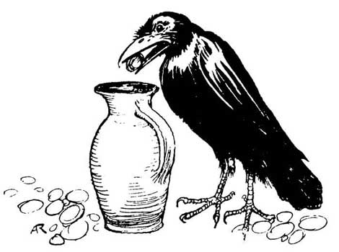

Career Unit, Des Moines Elementary School Counseling Grade 4, Lesson 1

Career Unit, Des Moines Elementary School Counseling Grade 4, Lesson 1
Compare and Contrast: The Crow and the Water Jug and Dancing in the Wings
