UNIT: Career Development Grade Level 5
ACTIVITY: McJobs Lesson 1

Career Standards: A. Students will acquire the skills to investigate the world of work in
relation to knowledge of self and to make informed career decisions.
- Students will understand the relationship between personal qualities,
education, training and the work of work.
B. Students will employ strategies to achieve future career goals with success and satisfaction.
Competencies: A:1 Develop Career Awareness
B:1 Acquire Career Information
C:1 Acquire Knowledge to Achieve Career Goals
Indicators: C:A1.1 Develop skills to locate, evaluate and interpret career information.
C:A1.2 Learn about the variety of traditional and nontraditional occupations.
C:B1.4 Know the various ways in which occupations can be classified
C:C1.6 Understand the importance of equality and access in career choice

Materials:

- Career Path Poster
- Career Path Web Poster
- “McDonald’s Jobs” handout for each group
- “Career Paths” handout for each group
- “Career Paths” answer sheet

Related Material:

- Website: www.mcdonalds.com

Vocabulary:

- Career paths – different groupings of jobs that share a common set of interests and skills for career success

Gathering:

On the blackboard or dry erase board, draw the McDonald’s Golden Arches. Ask students: “Does anyone know what this picture represents?”

Review Agenda/Before the Lesson:

“Today we are going to talk about McDonalds’s. We’re not going to talk about their tasty cheeseburgers or sundaes, but we are going to talk about some of the different kinds of jobs that McDonald’s employs. Did you know that McDonald’s employs over 1.5 million people around the world? That’s a lot of people and a lot of different jobs! Not all of the people who work for McDonald’s work in the restaurant making burgers. There are a lot of jobs within the McDonald’s Corporation or that work closely with McDonalds that many people don’t know about. Today we are going to learn about some of those jobs. Many of those jobs fall within the six career paths you learned about in 2nd, 3rd, and 4th grade.”

Using the Career Path and/or Career Path Web Posters, briefly review the six career paths.

During the Lesson:

Divide students into groups of 3 or 4. Give each group a copy of the “McDonald’s Jobs” and “Career Paths” handouts. Working as a group, instruct students to read each job square and discuss which career path each job matches. Students will write the job from each job square in the appropriate career path box. Students can write their own ideas on the blank square if they choose.

After the Lesson:

After groups are finished, have students discuss with their groups any jobs they are unfamiliar with.

Checking Out What You Learned/Assessment:

Place a blank copy of the “Career Paths” handout on the overhead or Elmo. Complete worksheet as a class, by having groups share their answers. Discuss answers.

Closing:

“Raise your hand if you were surprised by how many different kinds of jobs McDonald’s employs. What career path do you think you might like to work in when you are older?”

Reflective Questions:

What did my students gain from this lesson?
How did it impact their thinking, attitudes and abilities?
What things did I do well? How did I know?
In what way did the strategies I used enhance learning?
How does my assessment meet my lesson objective?

Notes:
As an alternative to the McJobs lesson you can bring in candy bar wrappers and have students work in groups and record all the different careers involved in the making and distribution of a candy bar. They may want to look at the ingredients on the wrapper. This helps students increase their awareness of different jobs.
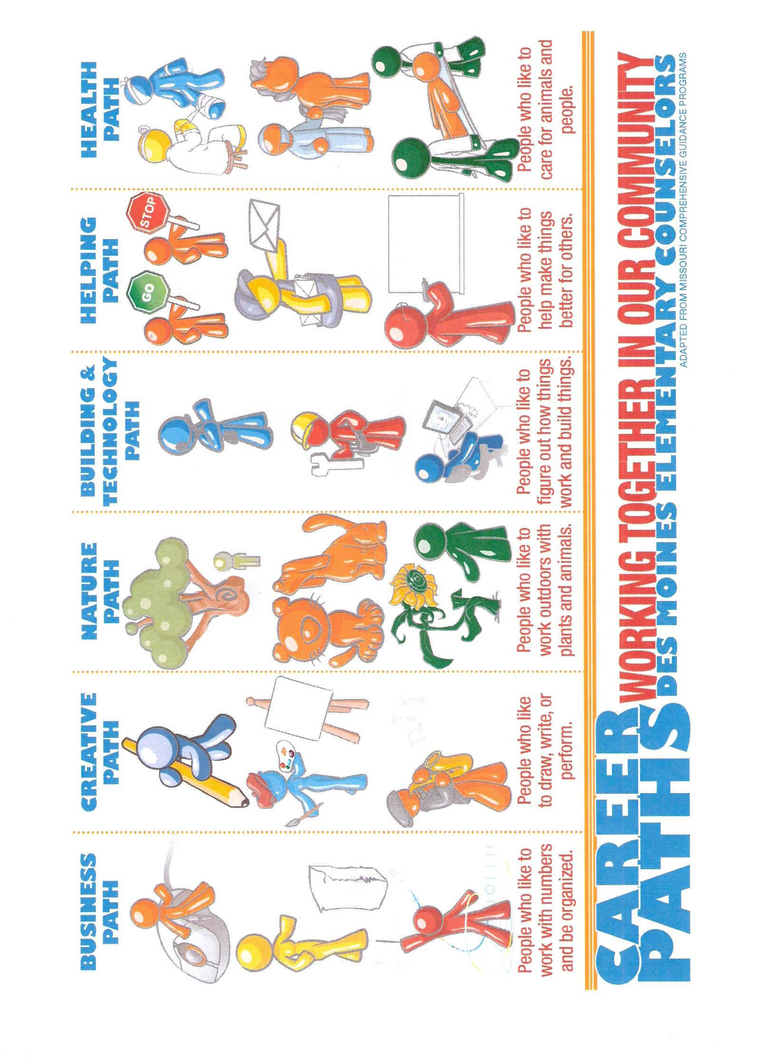

McDonald’s Job Squares
Write the following jobs in the correct path on the “Career Paths” handout.
Restaurant Manager  (Assigns duties for all employees) | Advertising Director  (Creates and designs commercials and other ads) | Construction Carpenter  (Builds new restaurants) | Cashier  (Works at the front counter waiting on customers)
Accountant  (Keeps financial records for the company) | Maintenance Groundskeeper  (Cares for the grounds outdoors) | Nutritionist  (Develops healthy menus) | Interior Designer  (Designs the inside of a restaurant)
Office Assistant  (Assists with office and record-keeping duties) | Real Estate Surveyor  (Explores land and samples soil for new restaurants) | Lawyer  (Helps McDonalds with legal problems) | Dietician  (Requires a special degree or license to research the details of McDonald’s food)
Realtor  (Buys and sells McDonald’s property) | Equipment Technician  (Works on the machines in the restaurant) | Trainers (Teachers)  (Teaches new employees how to do their jobs). | Architect  (Designs new McDonald’s restaurants)
Graphic Designer  (Creates art on computers to be used for ads) | Pilot/Air Travel  (Operates and flies airplanes for McDonalds) | Food Supplier to McDonalds  (Grow food and supply it directly to McDonalds) | List another job someone might have at McDonald’s

Career Unit, Des Moines Elementary School Counseling Grade 5, Lesson 1
Names __________________________________________
Career Paths

Business Path | Creative Path | Nature Path
Building & Technology Path | Helping Path | Health Path
Career Unit, Des Moines Elementary School Counseling Grade 5, Lesson 1

Career Paths Answer Sheet

Business Path | Creative Path | Nature Path
Accountant  Office Assistant  Realtor | Graphic  Designer  Advertising  Director  Interior Designer | Real Estate  Surveyor  Maintenance  Groundskeeper  Food Supplier
Building & Technology Path | Helping Path | Health Path
Construction Carpenter  Equipment  Technician  Pilot  Architect | Restaurant Manager  Cashier  Lawyer  Trainer | Nutritionist  Dietician  (The above two are similar. In general, dieticians are higher paid and must have a degree and/or license. Nutritionists do not. )
Career Unit, Des Moines Elementary School Counseling Grade 5, Lesson 1

