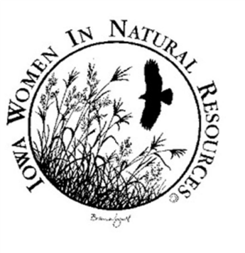
Scholarship Opportunity

Iowa Women in Natural Resources (IWINR) encourages young adults to pursue careers in the natural resources fields, which include jobs in wildlife, fisheries, and environmental management; forest resources; nongame specialists; environmental education; conservation law enforcement; and various related fields.

IWINR is sponsoring a nongender-based scholarship as noted below:

Requirements
- Enrolled in or plan to enroll in an Iowa university, college, or community college
- Pursuing a career in a natural resources field
- Currently working on a conservation project or are planning to work on one
- Write Project Description and Personal Essay
- Present project, in person or remotely at IWINR’s annual conference
o 2019 conference is planned for Hartman Reserve Nature Center on February 14, 2019
o 20-30 minute presentation
o Details and flexibility related to presentation format and travel to be discussed with the successful
applicant

Scholarship Conditions
IWINR will award a one-time scholarship of $500.00 the applicant who receives the highest score awarded by the Selection Committee. The successful applicant must submit a final project report to IWINR upon completion of the project. The stipend will be payable to the school, not the recipient, upon completion of the project. The applicant with the highest score will be invited to present at the IWINR conference.

Selection Criteria
The Selection Committee will score applications based on the following criteria:
- Project Description - 50 points
  - How does your project relate to conservation as it applies to science and our natural resources
  - Completeness of project description
  - Expected outcome of project
  - Feasibility of implementing project outcome
- Personal Essay - 50 points
  - Education goals
  - Career goals
  - Personal philosophy on how individuals can make positive impacts which affect the environment and natural resources
  - Employment/volunteer experience

Applications must be postmarked by November 15th. Selected award recipient will be notified by phone by December 1st.

Please mail completed application and supporting information to:

Iowa Women in Natural Resources
Attn: Lori Eberhard
2659 Wyth Road
Waterloo, IA 50701

