**UNIT: Career Development Grade Level K**

**ACTIVITY: Different** Places, Tools and Jobs **Lesson 3**

|  |
| --- |
| Career Standards: A. Students will acquire the skills to investigate the world of work in relation to knowledge of self and to make informed career decisions. |
| Competencies: C:A1 Develop Career Awareness |
| Indicators: C:A1.2 Learn about the variety of traditional and nontraditional occupations  C:A1.3 Develop an awareness of personal abilities, skills, interests and motivations |

Materials:

* Large job pictures (gardener, doctor, scientist, firefighter, artist, dancer, construction worker)
* Large places pictures (school, hospital, construction site, zoo, stage, office)
* Community Helper Pocket Flash Cards
* White boards and markers for each student (if available)
* Job props (if available)
* “Matching Worksheet” for each student

Related Materials:

* Who uses this? by Margaret Miller

Vocabulary:

* Job – work
* Talent – something a person can do well or is good at
* Tool – something a person uses to do their job

Gathering:

Select one or two of the provided job pictures and show students. Ask students: “What do you think this person’s job is?” “How do you know?”

Review Agenda/Before the Lesson:

Say to students: “Today we will learn about different kinds of jobs – like the ones you just saw. Before we do that, I want you to think about last week’s lesson. Last week we learned how talents are important in choosing a job. Remember, a talent is something a person can do well or is good at. What was Cosmo’s talent? If Cosmo had a job, what do you think his job would be?”

During the Lesson:

Show students a picture of a school (included in “places pictures”). “What kinds of jobs do people in our school have?” (i.e. principal, school nurse, cafeteria staff, custodial staff, counselor, bus driver, music teacher…) Ask students what a principal might be good at, or what talents they might have? Nurse? Cook? Pick one or two additional “places pictures” and continue activity (choose developmentally appropriate pictures to match each class’s readiness level). Ask students what jobs people might have in each place.

After the Lesson:

In lieu of the matching worksheet below you can hand out a white board and marker for each student. Show the students a community helper career card and have the students draw a tool that goes with each career card. Other options: Have one student come forward and show them one of the community helper career cards. Have that student give examples of what that career is or what tools that person may use without use the name of that career. The rest of the students guess the career. Or group students into pairs. Give each pair a Community Helper Pocket Flash Card. Show students Community Helper Tool Cards a specific job might use. (or use job props if available) Ask students to raise their job picture in the air with their partner if it fits with the tools shown. Emphasize how boys and girls can have any of the jobs presented. Intentionally emphasize job cards represented by non-stereotyped/nontraditional genders (i.e. police officer represented by a woman, nurse represented by a man…). Tell students: “Boys and girls are equally able to do any job they want to as long as they believe in themselves and try hard.”

Checking Out What You Learned/Assessment:

If time permits you can have each student complete the matching worksheet.

Closing:

After students have completed their worksheet, ask students “What will your job be when you grow up?”

Reflective Questions:

*What did my students gain from this lesson*?

*How did it impact their thinking, attitudes and abilities*?

*What things did I do well*? *How did I know?*

*In what way did the strategies I used enhance learning*?

*How does my assessment meet my lesson objective*?

Notes:

Counselor may want to review with students how to use the Community Helper Pocket Flash Cards. They are thin, easily bend, and must be used with respect.

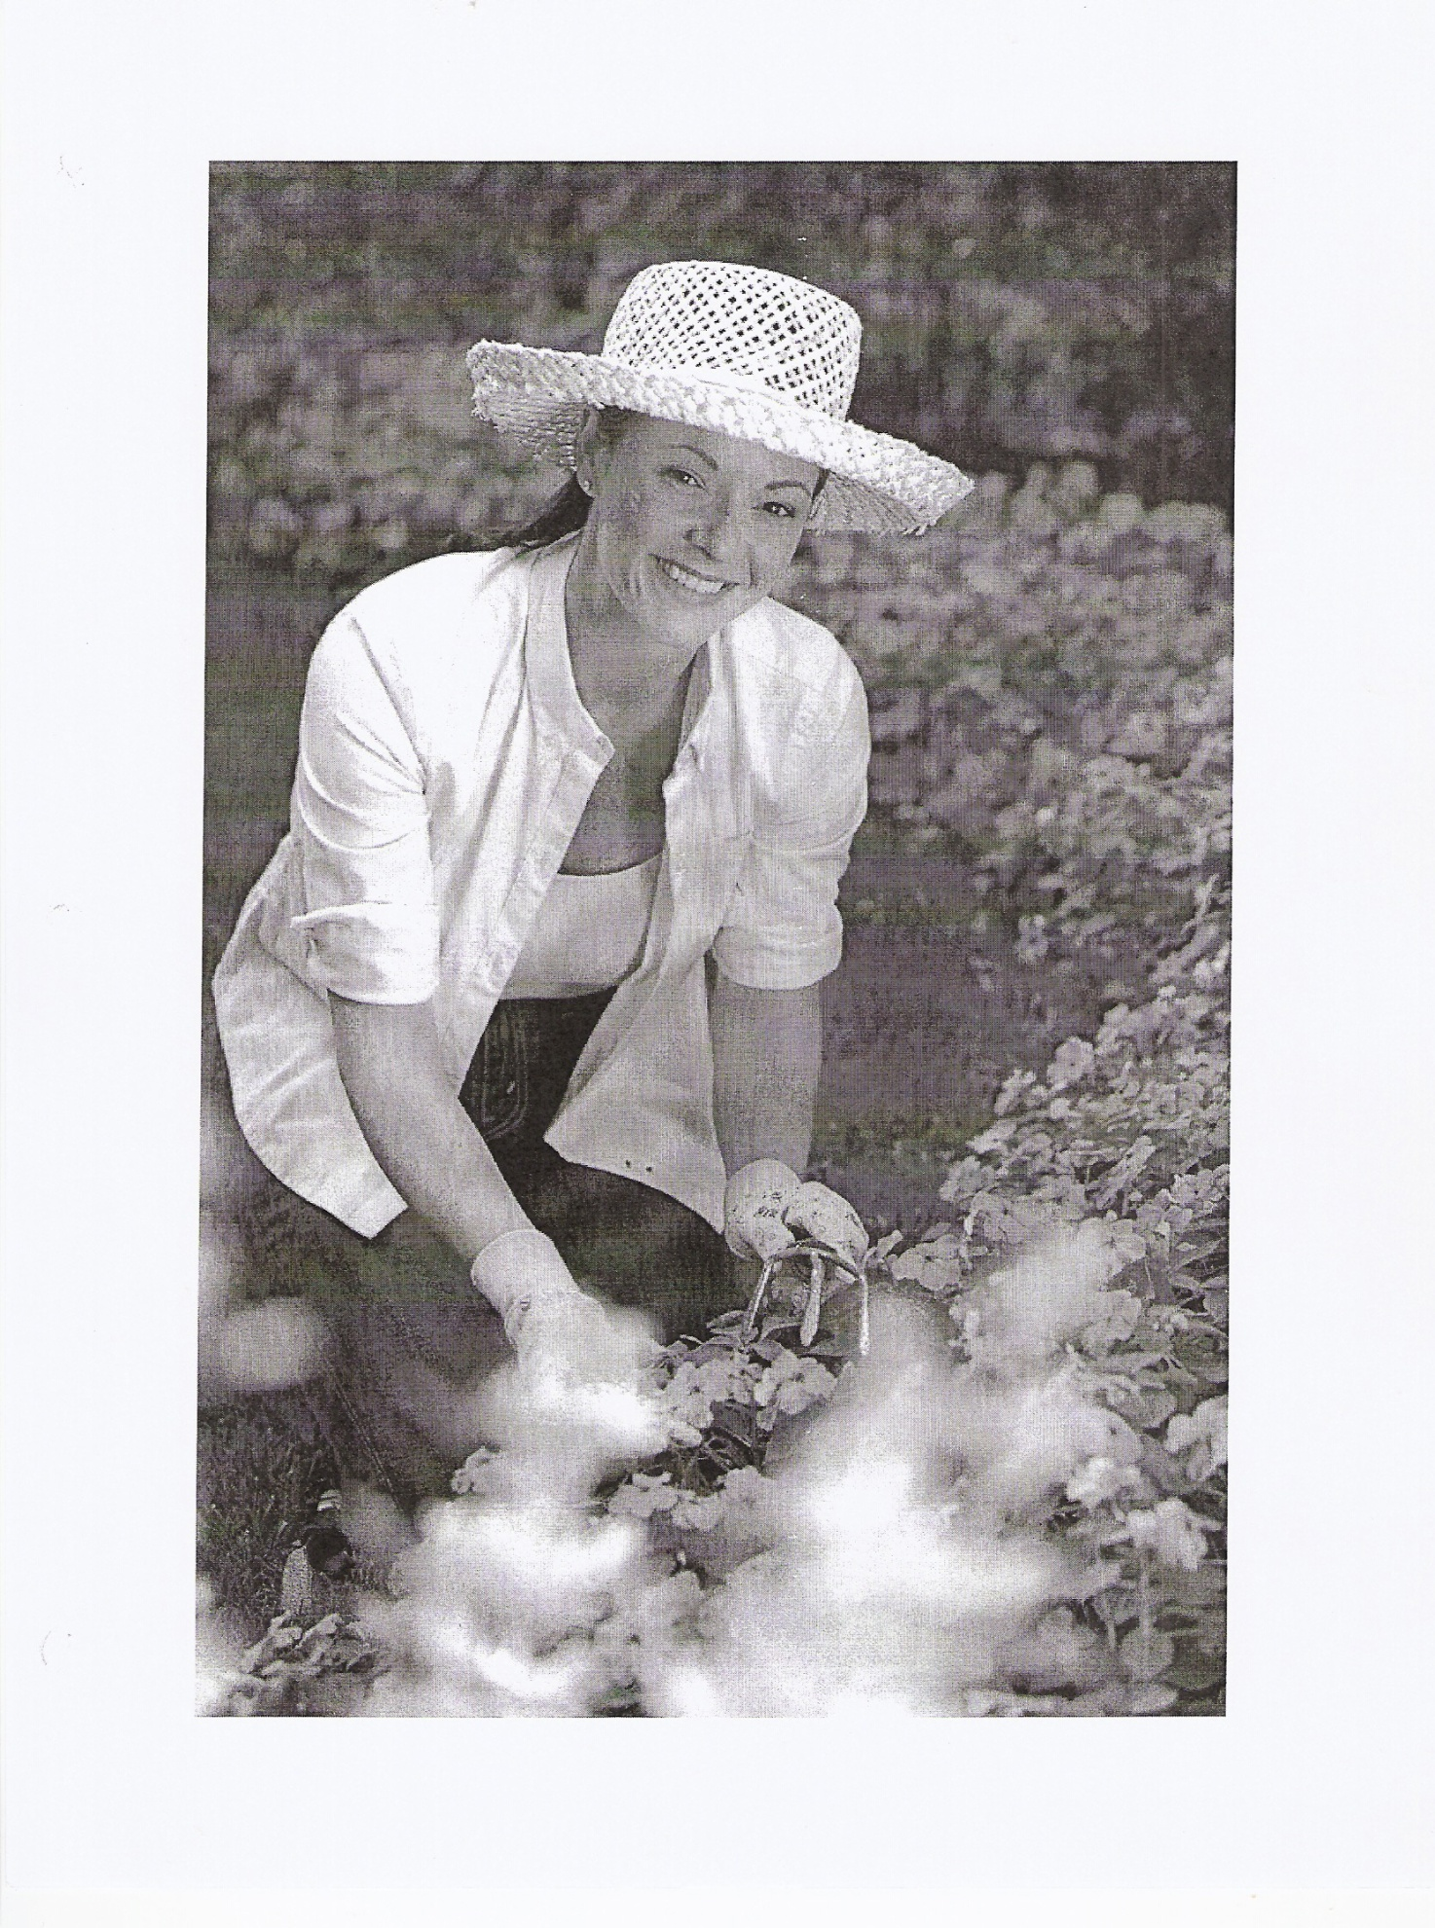

Career Unit, Des Moines Elementary School Counseling Grade K, Lesson 3



Career Unit, Des Moines Elementary School Counseling Grade K, Lesson 3

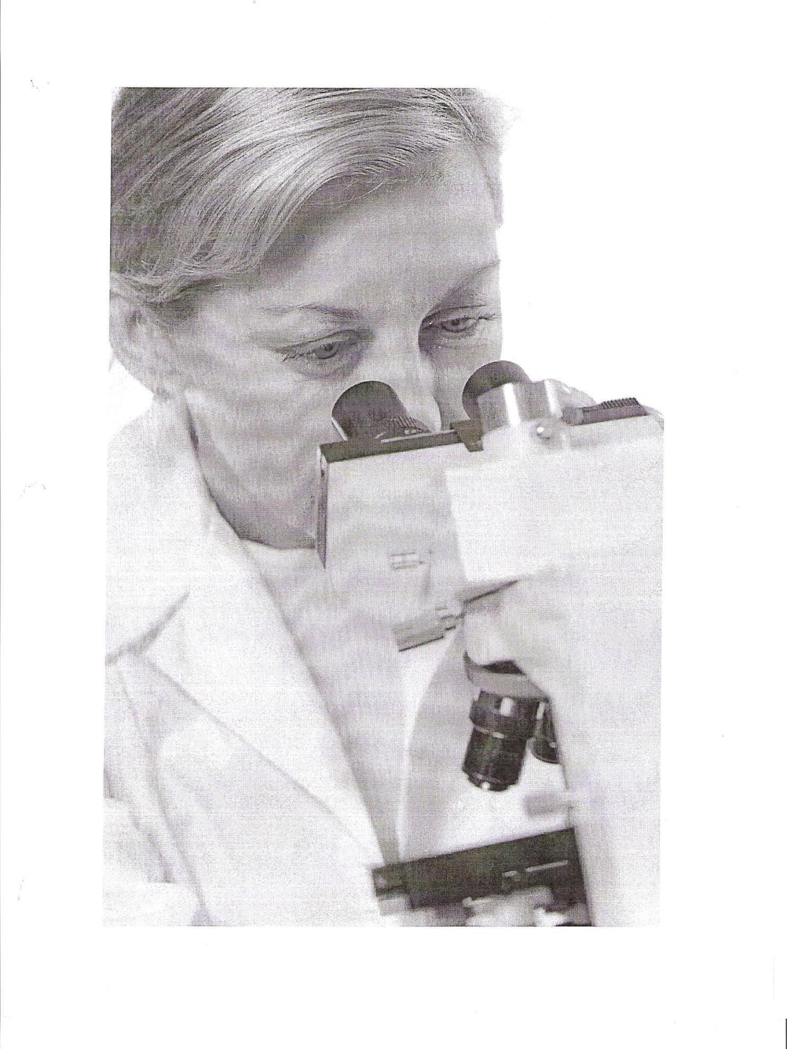

Career Unit, Des Moines Elementary School Counseling Grade K, Lesson 3



Career Unit Des Moines Elementary School Counseling Grade K, Lesson 3



Career Unit, Des Moines Elementary School Counseling Grade K, Lesson 3

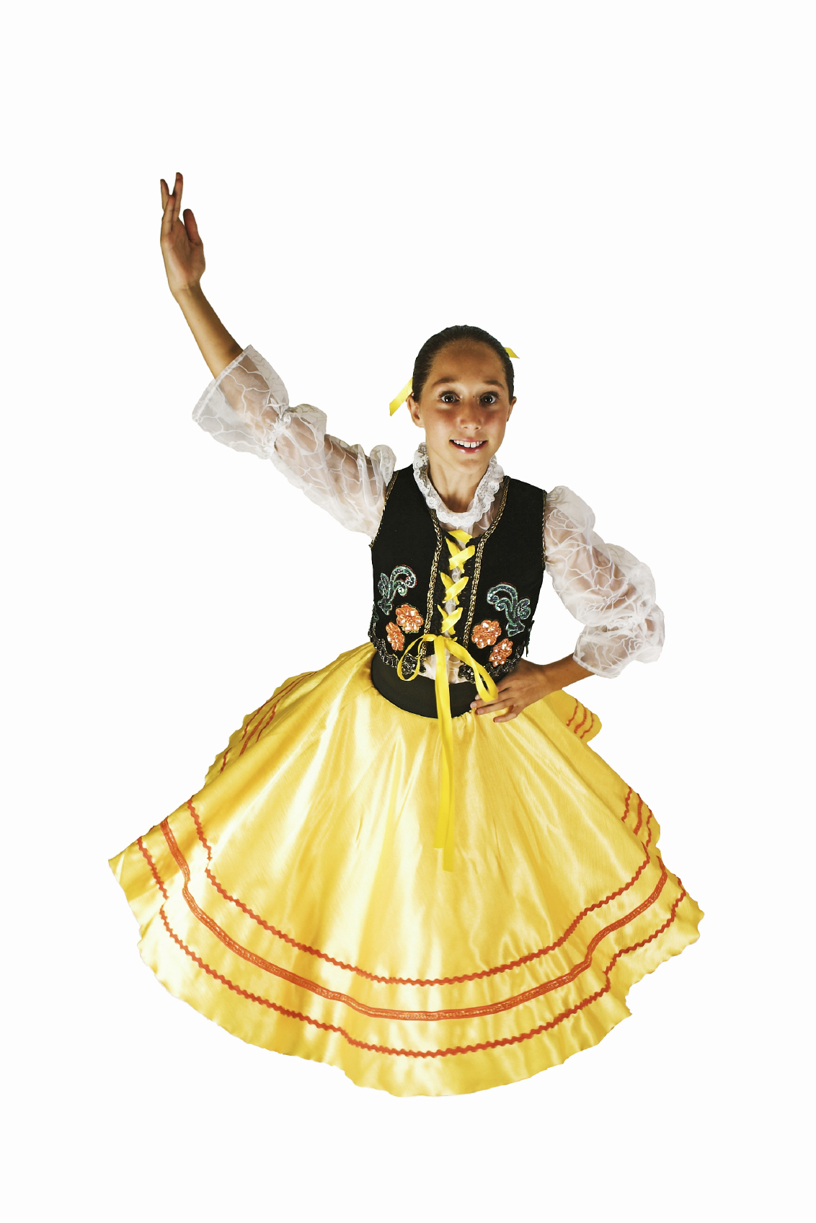

Career Unit, Des Moines Elementary School Counseling Grade K, Lesson 3



Career Unit, Des Moines Elementary School Counseling Grade K, Lesson 3

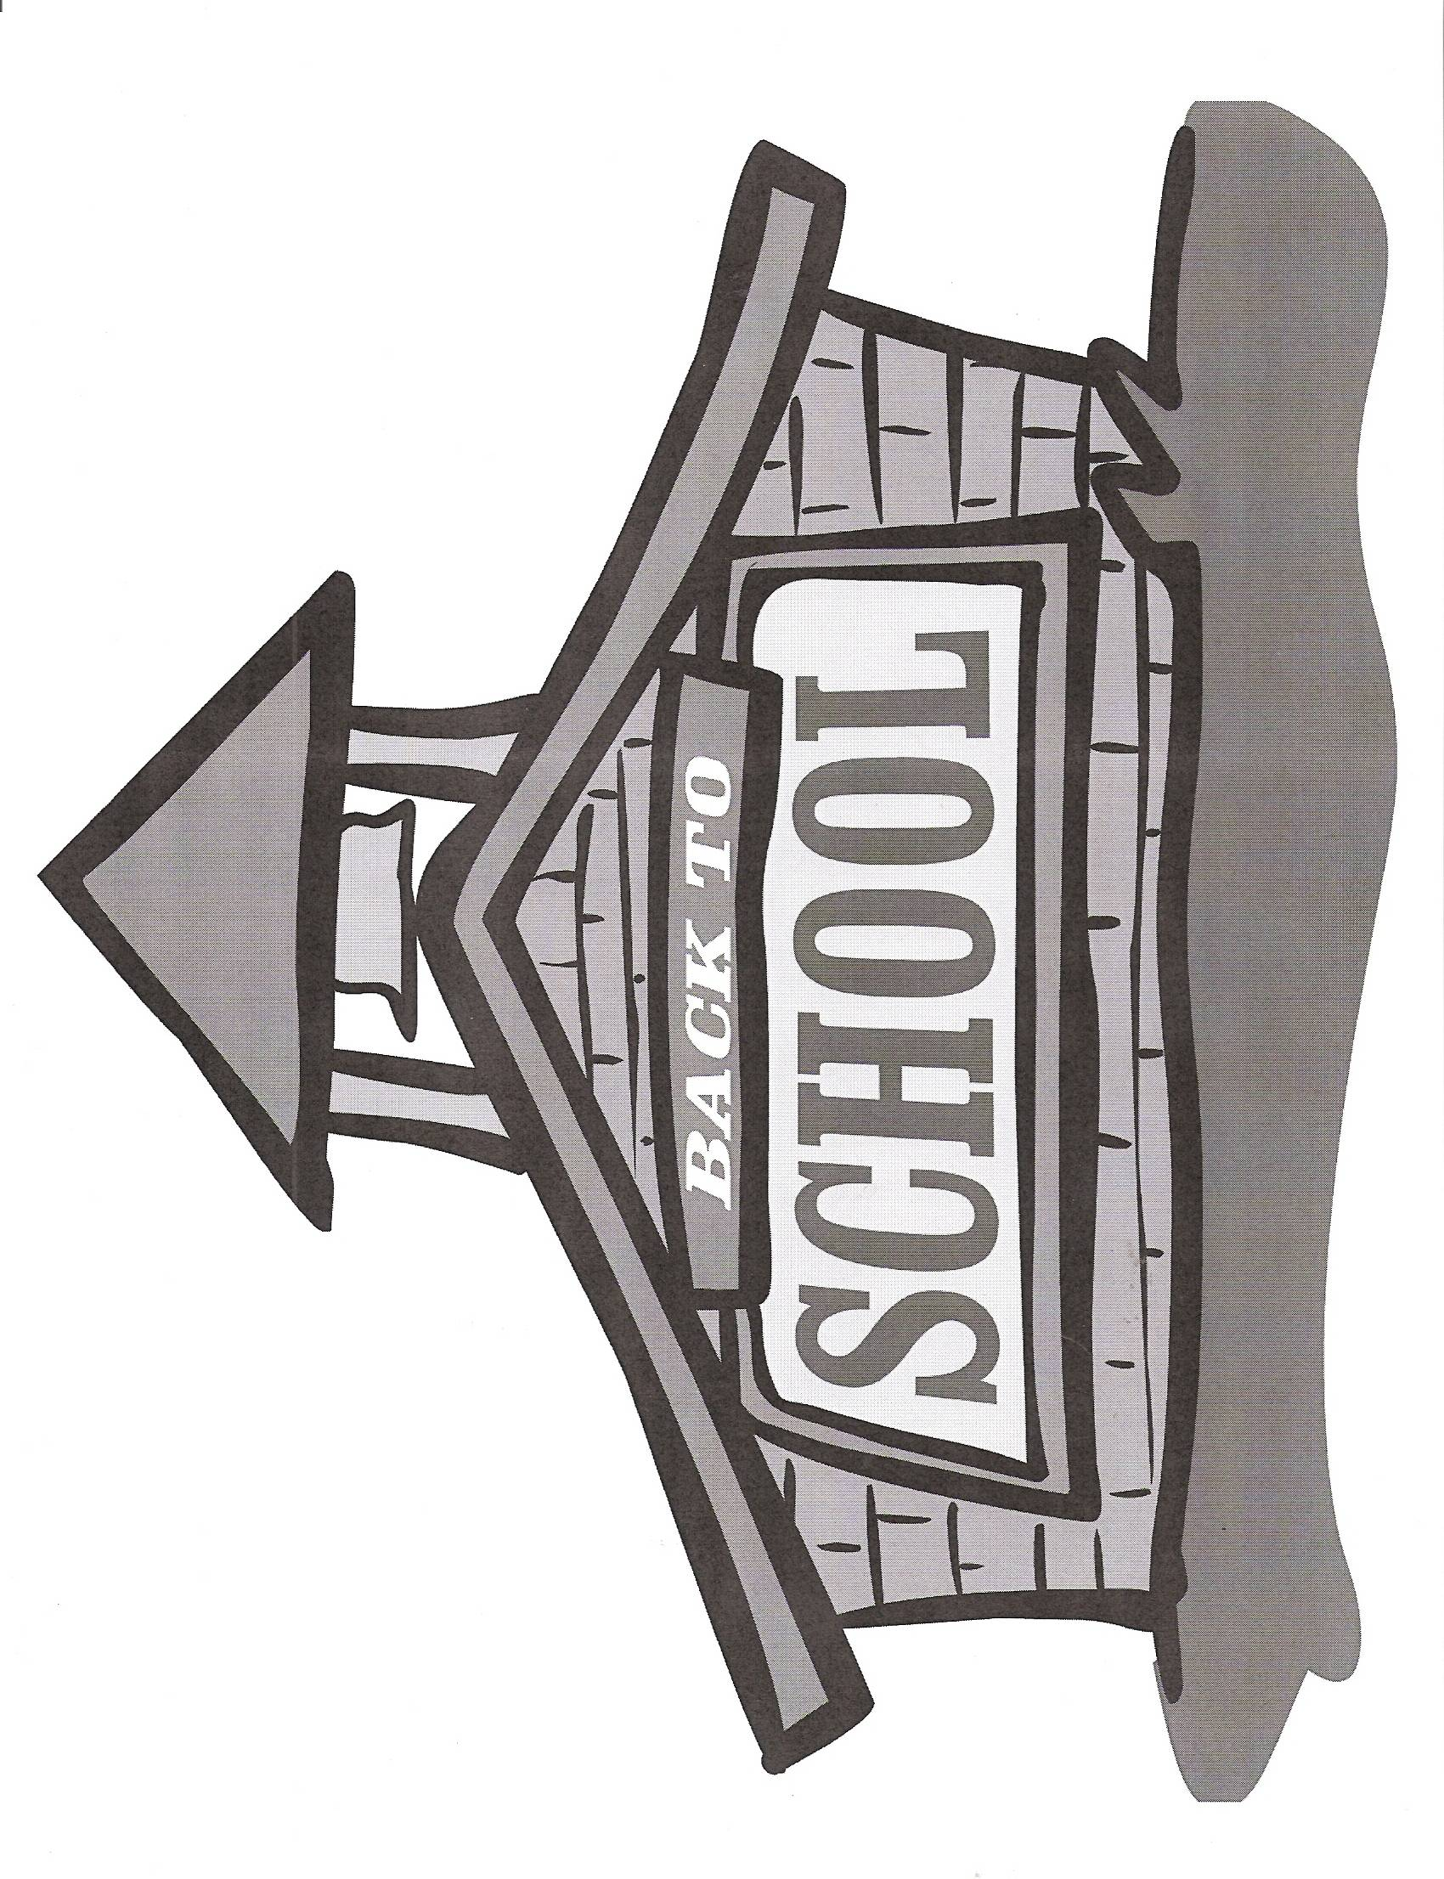Career Unit, Des Moines Elementary School Counseling Grade K, Lesson 3



Career Unit, Des Moines Elementary School Counseling Grade K, Lesson 3

Career Unit Grade K, Lesson 3



Career Unit, Des Moines Elementary School Counseling Grade K, Lesson 3

Career Unit Grade K, Lesson 3

**MCj02313560000[1]**

Career Unit, Des Moines Elementary School Counseling Grade K, Lesson 3



Career Unit, Des Moines Elementary School Counseling Grade K, Lesson 3

