UNIT: Career Development Grade Level 2
ACTIVITY: Intro to Career Pathways Lesson 2

Career Standards: B. Students will employ strategies to achieve future career goals with success and satisfaction.
C. Students will understand the relationship between personal qualities, education, training and the world of work.
Competencies: C:B1 Acquire Career Information
C:C1 Acquire Knowledge to Achieve Career Goals
Indicators: C:B1.4 Know the various ways in which occupations can be classified
C:C1.3 Identify personal preferences and interests influencing career choice and success

Materials:

- Career Path Poster
- Career Path Mini-Poster for each small group
- Career Path Web Poster
- Interest Activity Sheet

Vocabulary:

- Path – a way that leads a person to the place they need to go
- Career paths – different groups of jobs that have things in common
- Interests – things a person likes to do

Gathering:

Pick a student to go to a specific place. (i.e. to the pencil sharpener, sink, door…) Have additional students go to the same destination by taking a different path. (As an optional activity, tell students they are going to take a short walk together. (Pick a specific destination within the school. I.e. gym, office, lunch room…) Choose a student to lead the way. Instruct students to follow the leader without talking. Once students get to the destination, choose another student to lead the way back to the room.

Review Agenda/Before the Lesson:

Ask students: “How did you know where to go?” (They know the path to take.) “Paths are ways that lead you to the places you need to go, like a trail or a road. We are going to learn about a different kind of path today. The paths we will learn about are not like the paths you take to the gym or the cafeteria. Instead, we will learn about 6 different paths you could take when you grow up. They are called “career paths.” Career paths lead people to the jobs they could have when they are adults. Some people take the same path. Some people take different paths.”

During the Lesson:

Ask students to identify jobs they are aware of. Popcorn around the room as students respond. Ask students why there are so many different kinds of jobs? (Because different jobs are for people who like to do different things and activities.) Different jobs fit in different career paths. The most important things that help people decide which path to take are their favorite and least favorite things to do. Encourage students to remember the previous lesson and the things they wrote or drew on their activity sheets.

Briefly introduce the career paths by examining the Career Path and Web Posters (i.e. “Business Path” consists of people who like to work with numbers and be organized.) Continue to introduce the career paths and pictures on the web in order. (i.e. Business Path, Creative Path, Nature Path, Building and Technology Path, Helping Path, and Health Path.)

After the Lesson:

After the lesson, tell students they will get a chance to match interests to the appropriate career path. Divide students into groups. Cut out and give each group 2 or 3 items on the Interest Activity Sheet. Give students time to read each interest and match with the appropriate career path. Have students write the path next to the interest. Encourage students to use their Career Path Mini Posters for clues.

Checking Out What You Learned/Assessment:

As a class, share answers from the Interest Activity Sheet.

Closing:

Emphasize the connection between interests and career paths. Have students close their eyes and think of their favorite thing to do. Ask students what career path they may choose when they grow up.

Reflective Questions:

What did my students gain from this lesson?
How did it impact their thinking, attitudes and abilities?
What things did I do well? How did I know?
In what way did the strategies I used enhance learning?
How does my assessment meet my lesson objective?

Notes:
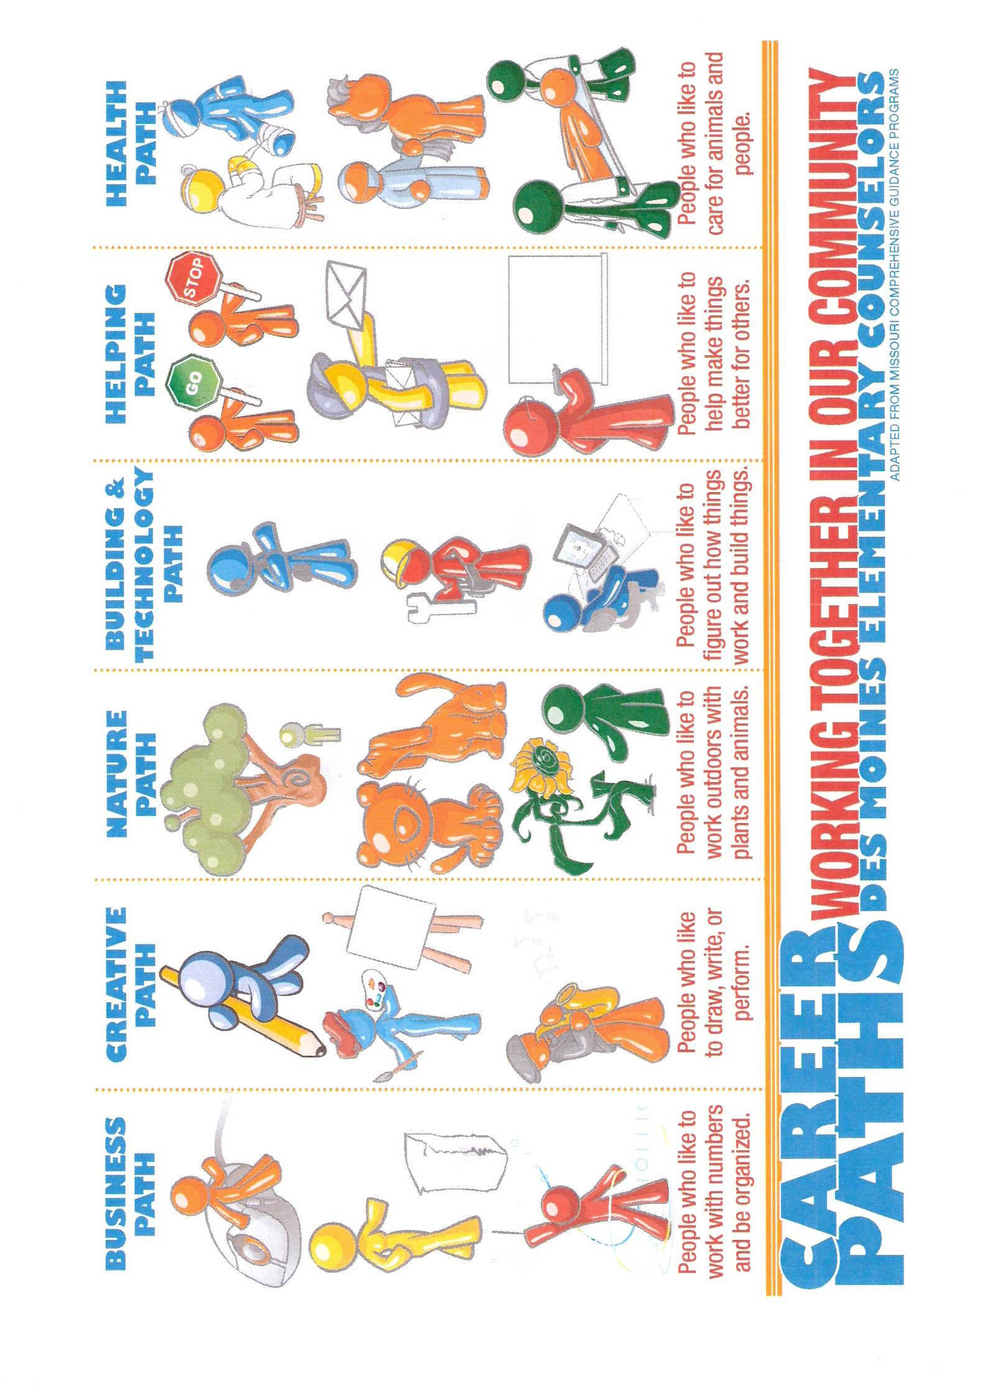

Interest Activity Sheet
Directions: Write the career path that matches best next to each interest.
- Favorite subject in school is math.
- Favorite subject in school is art.
- Favorite subject in school is music.
- Enjoys building things.
- Enjoys planting flowers.
- Enjoys teaching friends how to do something new.
- Likes to take care of their brothers when they are sick.
- Likes to help their friends at school.
- Likes to help their mom clean the house.
- Likes to help their dad cook dinner.
- Likes to do number puzzles for fun.
- Enjoys singing and dancing.
- Enjoys fixing things around the house.
- Enjoys taking care of their dog and cat.
- Enjoys being outside in the summer and winter.
- Likes to keep their room picked up and organized.

