UNIT: FRIENDSHIP/ SOCIAL COMPETENCIES Grade Level 1
ACTIVITY: Book: All Kinds of Friends, Even Green Lesson 2

Personal/Social Standards:
A: Students will acquire the knowledge, attitudes and interpersonal skills to help them understand.
and respect self and others
Competencies:
PS:A1 Acquire self knowledge
PS:A2 Acquire interpersonal skills
Indicators:
PS:A1.1 Develop positive attitudes toward self as a unique and worthy person
PS:A2.3 Recognize, accept, respect and appreciate individual differences

Materials

- Book: All Kinds of Friends, Even Green! by Ellen Senisi (non-fiction)
- Use of chalkboard

Vocabulary

- Unique – something that makes you special or different from others.
- Same - alike
- Different – not like; not the same

Gathering

“Stand up if you have a friend that is taller than you (repeat: shorter than you, just as tall as you).”

Before the Lesson/Review Agenda

“If you are the same size then you are alike, if you are not the same size, then you are a different. The opposite of same is different. We are all alike in many ways and different in many ways.”
Show cover of book. Share the title and author. “What do you think the story is about? What do you think will happen? What question would you like to ask?”

During the Lesson

Read the book using read aloud strategies.

After the Lesson

- “What did Moses learn about friends?”
- “Unique means something that makes you special or different from others. Can you think of something you do that not everyone your age is able to do?”
- “Disabled means someone cannot do some things that other people the same age can do. Does anyone here have a Grandma or Grandpa who uses a hearing aid? They are disabled, because they are not able to hear as well as other people their age.”

Checking Out What You Learned

“Like Moses we will write a class paragraph about friends.”

Write FRIENDS on the board. Write these starter sentences and ask for ideas to complete. (Repeat each sentence as needed)
- A friend is someone who .
- A friend might be _______ or a friend might be_______. (Use opposites here)
- Everyone likes a friend who________.

Read the paragraph aloud together.

Closing

TTYPA and tell how you are a special friend.

Notes:

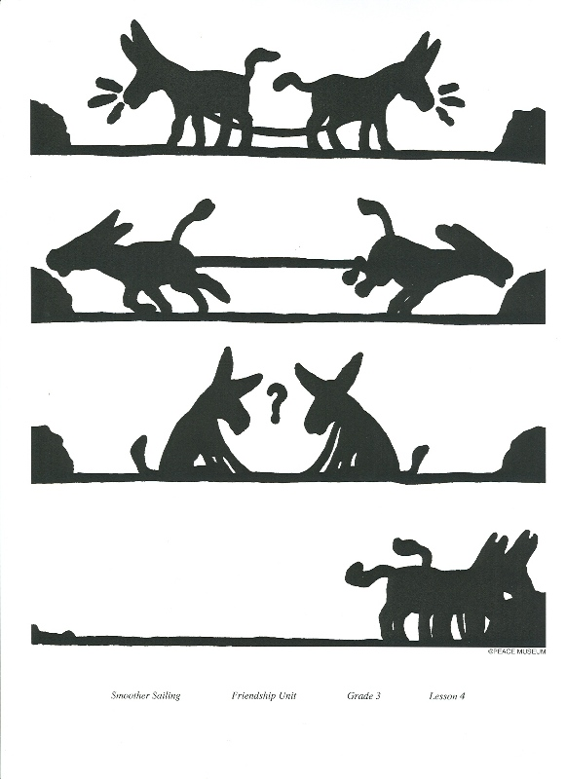

Name: ____________________________ Date: __________________

After reading “All Kinds of Friends, Even Green”, write about what you think makes a good friend. Fill in the sentences below.

To me, a friend is someone who _______________. A friend might be _______________ or a friend might be ________________. Everyone likes a friend who is _____________________.

Name: ____________________________ Date: __________________

After reading “All Kinds of Friends, Even Green”, write about what you think makes a good friend. Fill in the sentences below.

To me, a friend is someone who _______________. A friend might be _______________ or a friend might be ________________. Everyone likes a friend who is _____________________.

