Academic Planner for Students
Based on your assigned Academic (High School Graduation) Plan, you must meet all credit and course requirements. The goal is to meet each requirement for each grade level.
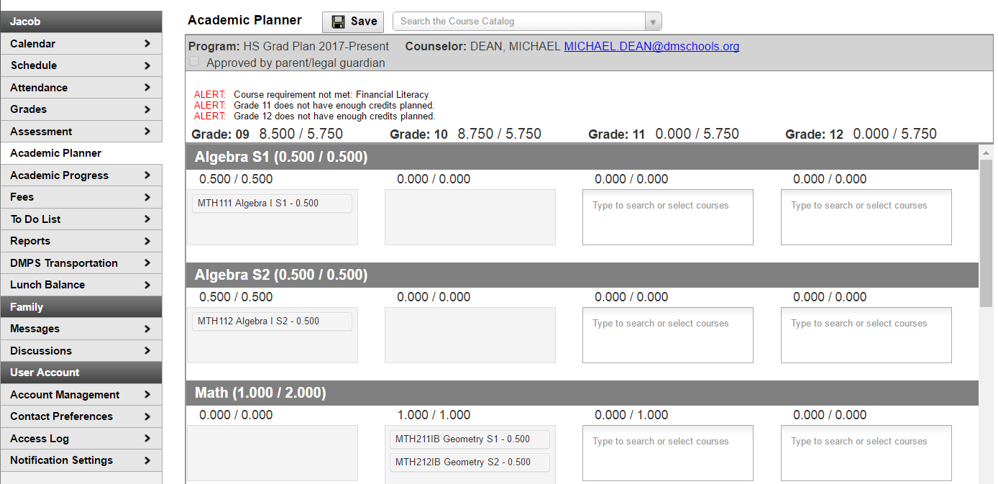

Academic Program Information
When first accessing the Academic Planner from your portal account, verify the Academic (High School Graduation) Plan. If not plan is showing, you will need to contact your counselor before you will be able to proceed. If there is a plan listed, select the desired Post Grad Location and Post Grad Plans. Click the Next button when finished.

Add Courses from the Course Catalog (Searching)
If you know the name of the course, enter the name or partial name in the search field. Matching results will display below the search box. Click on a course name to see more information about the course.
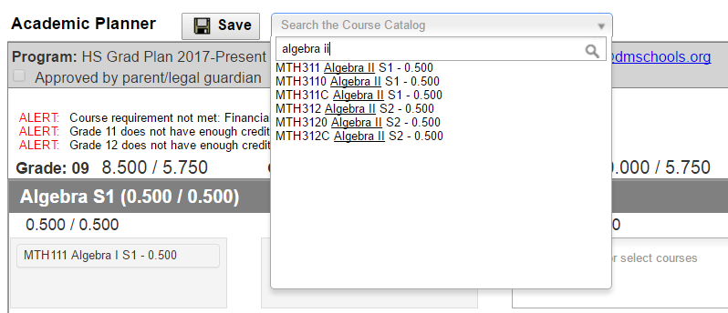

When a course is chosen, a description displays providing more information about the course, any prerequisites, total number of credits given, course fees (if any), and an option to add that course to the plan for a specific grade level.
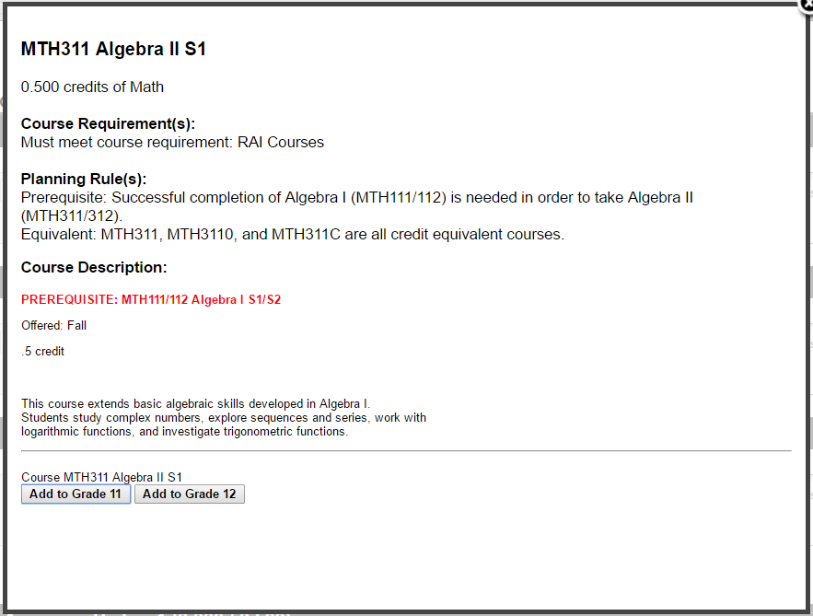
If this is the course you want to take, click the Add to Grade button. This places the course on your plan in the indicated grade level for that credit type. Only the grade levels that are available will be shown. You cannot add a course to a past or current grade level.
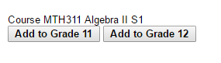

Add Courses (by Grade Level and Credit Type)
- Click in the text box below the number of credits for a certain grade level. Courses meeting that credit type will display.
- Choose the desired course(s). They will display in the text box and your total number of credits chosen is updated. The credits assigned to a course appear after the course name.
- Add enough credits for all grade levels as needed. When the number of requirements is met, the alert stating not enough credits selected disappears.
- Repeat these steps for each credit type. At the end of the process, you should have a clear idea of what courses you will be taking in each grade level.
- Click the Save icon when finished.
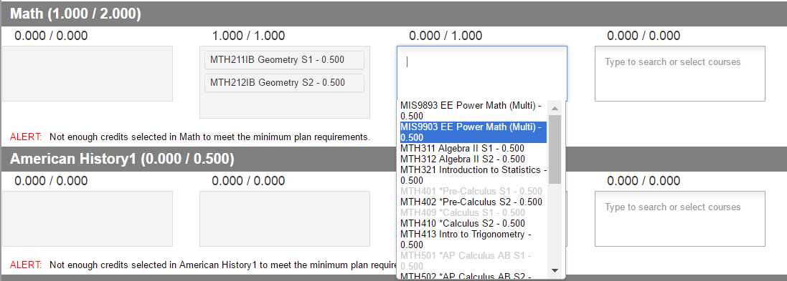

Academic Plan Alerts and Warnings
Each time a change is made to the Academic Plan, all rules and requirements are reevaluated and alerts and messages are updated. Once the alerts have been satisfied, they will be removed.
Warnings
- Warnings display in black font when there is a failure to meet a Credit Requirement or a Course Requirement.
- Plans can still be saved when warnings exist.
Alerts and Errors
- If you have an Academic Plan with an error, you will not be able to save the changes from the Portal.
- Alerts display when:
    - A grade does not have enough credits planned.
    - A credit type does not have enough credits planned.
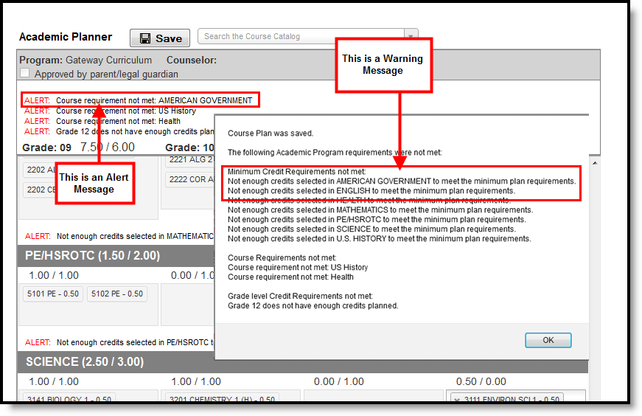

Course Display
Courses that appear in the dropdown lists are pulled from your most future enrollment calendar, based on the primary enrollment only.
- Courses that have been completed (have been posted to the transcript) and in-progress courses (you are currently scheduled into) display as such when hovering over the course.
- Courses that can be taken multiple times display for each grade level.
- Courses that have planning rules associated with them that have not been satisfied display in gray text.
  - When a parent course is removed from the course plan, the child courses are also removed.
- Planned courses that do not meet planning rules assigned on the course display as a planning rule violation.
- If you have not taken or planned a required course tied to a course requirement, an alert displays.
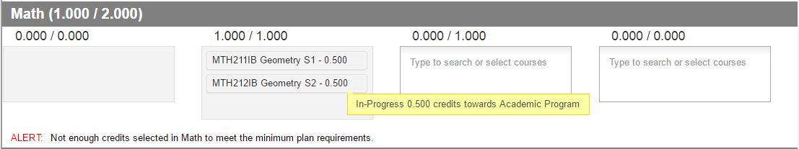
Credits Earned, Credits In-Progress
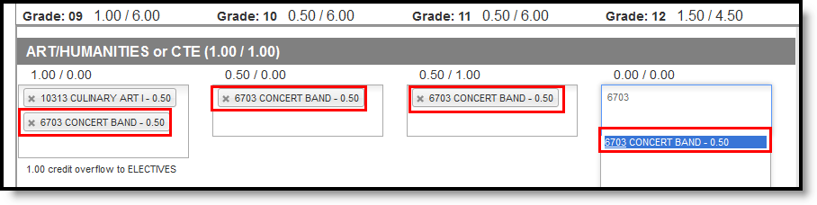
Repeating Course
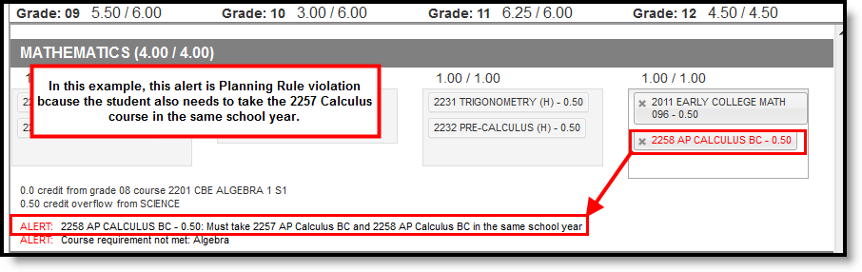
Planning Rule Violation
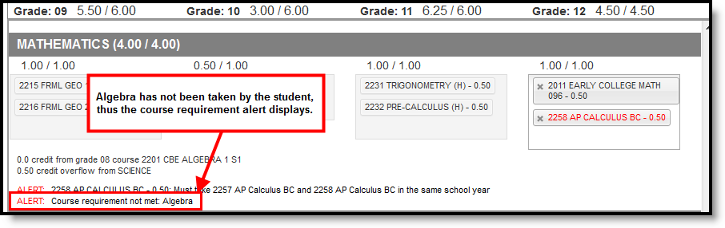
Course Requirement Violation

Credit Display
Existing credits applied to high school courses display in the credit type section to which they apply. Any credit assigned to the credit type that is considered overflow displays as well.
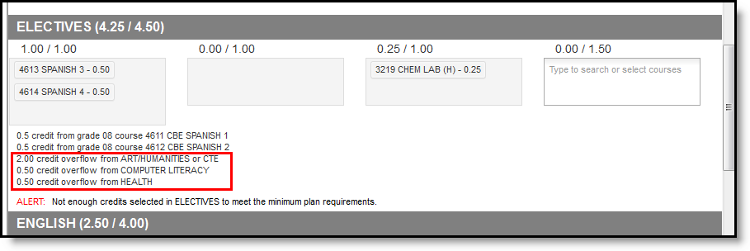

Parent and Guardian Approval
When you are finished building your academic plan, have your parent(s)/guardian(s) review it by having them log into their Parent Portal account and mark the Approved by parent/legal guardian checkbox.
